State of Palestine  Ministry Of Education &Higher EducationDirectorate Of Education -Tulkarm  Shoufah Mixed School | 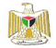  2012/2013 | دوله فلسطين  وزارة التربية والتعليم العالي  مديرية التربية والتعليم ـــــ طولكرم  مدرسة شوفه ث م  الرقم الوطني
التاريخ: .... \ \ 2013 | الصف: .............5........ | المبحث:...............E..............................
الزمن: حصه | الاسم:

- Read and answer 7
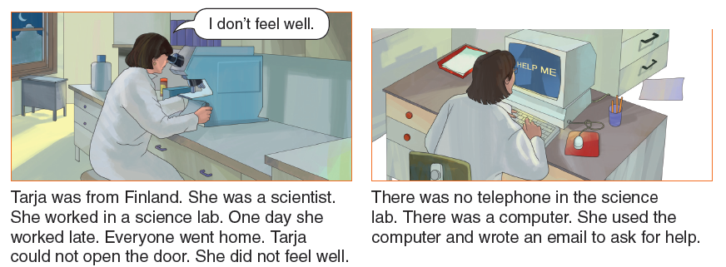
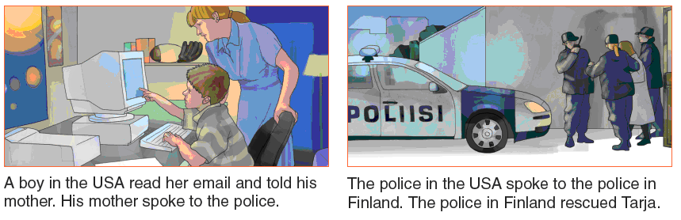

- Who rescued Tarja? ----------------------------------------------
- Was there a telephone in the science lab? -----------------------
- Complete
  - Tarja used the-------------- and wrote an email.
- Correct
Tarja worked in a farming lab.
- Tick
Tarja feels very well. □

- Circle
The police in Finlandrescued / visitedTarja.

7- She refers to -------------------

Language
- Read and circle 3
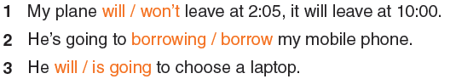

2-Read and write 5
What will happen in the future?
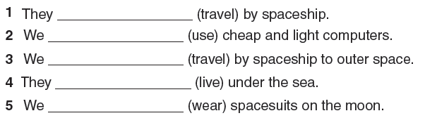
3-Think and complete 3

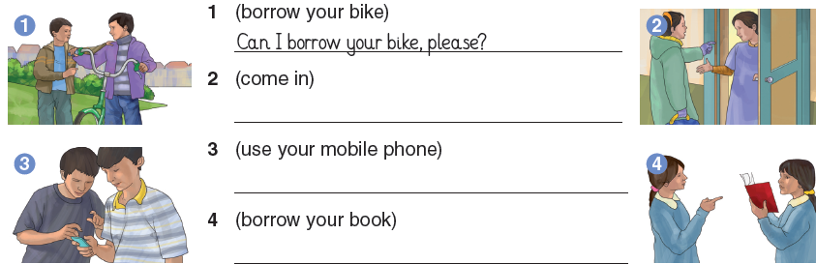

4-Read and complete 3
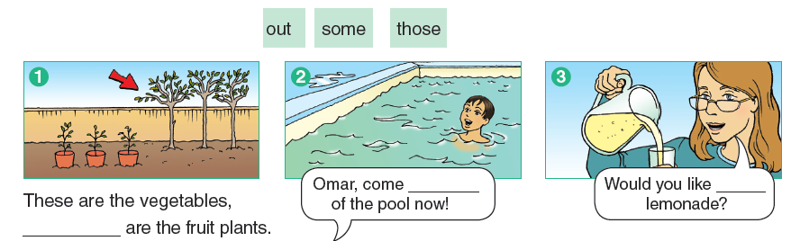
5- Read and tick 4
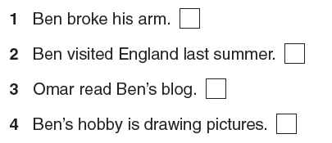

6- Write correct sentences4
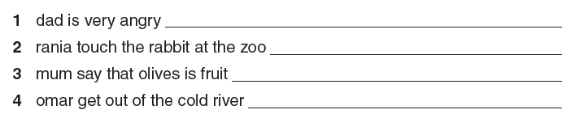
7- Write and complete3

laughed Both happy angry
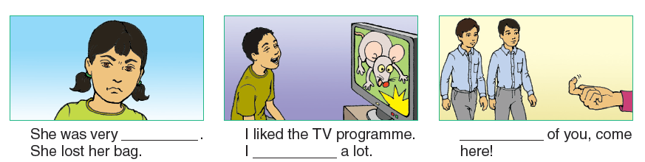

8- Think and write 4
What happened yesterday?
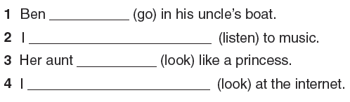
9- Listen and match4
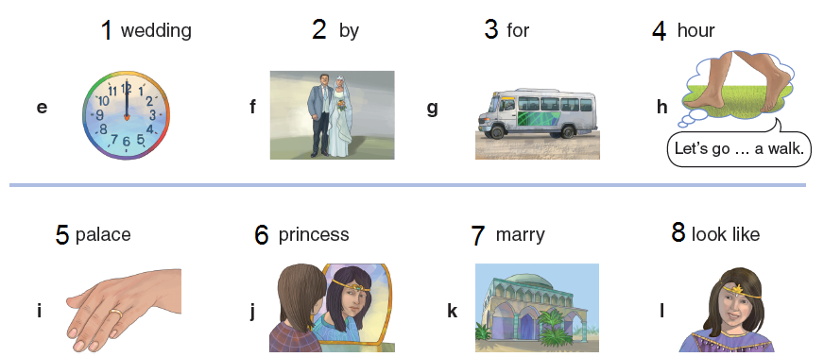

- Listen and circle 4
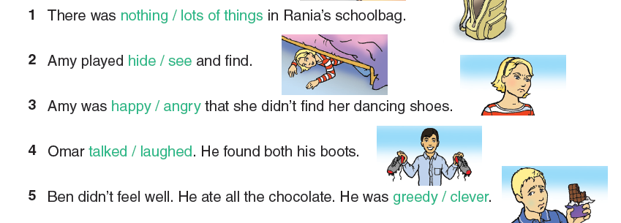
- Listen and choose 4
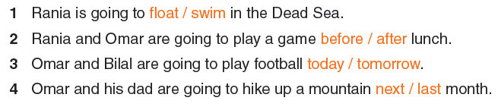

12-Answer the questions 2
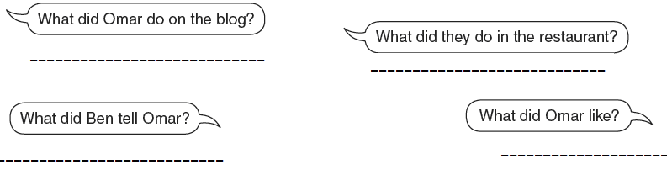

مزيد من اختبارات اللغة الانجليزية للصف الخامس من هنا
https://www.wepal.net/library/?app=content.list&level=5&semester=2&subject=5&type=2

