اختبار نهاية الفصل الدراسي الثاني للعام 2015 / 2016 م
دولـــــــــــــــــــــــــــــــــــــــــــــــــة فلســــــــــــــــــــــــــــــــــــــــــــــــــــــــــــــــــــــطين

40

وزارة الــتــــــــــــربـــــيــــــــــة والـــتــعــــلــيـم الـــعــــالـــــــــــــــــــــــــــــــــي اسم الطالب: .......................
مـــديــــريــــــة الـــتـربـــيـــة والــتـعــلـيم-شــــرق خــان يـــونـــس الصف: الخامس صباحي
المادة: اللغة الانجليزية
1) Listening (5 Marks)
1) Listen and number the pictures: - 5 points
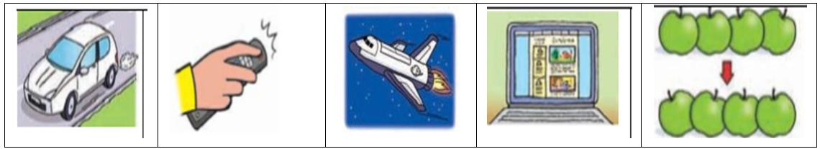

2) Speaking (11.5 Marks)
2) Match :- 2.5 points
1- What are you doing now ? | ( ) My favourit animal isa giraffe .
2- What did the farmer buy ? | ( ) On the internet .
3- When did Ben break his leg ? | ( ) I'm reading a story .
4- Where can you see ablog ? | ( ) He bought a goat .
5- What's your favourit animal ? | ( ) He broke his leg last summer

a) Complete the dialogue :- 8 points
Omar : Where did you go ………………….. weekend?
animal
do
last
giraffe
did
any
zoo
touched

I went to the ………………………. . Ben:
Omar : What's your favourite ……………………… ?
Ben : My favourite animal is a …………………….. .
Omar : What did you ……………….. there?
Ben : I…………………. the giraffe .
Omar : Did you give it ………………… fruit ?
Ben : yes, I ………………… .
b) What would you say in the following situation 1 points
1- When you start a story?
a) In the end b) once upon a time c) I'm sorry
تابع خامس صباحي – 2 -
3) Reading: (5 Marks)
Read the passage then answer the questions:-
Omar bought a new laptop last summer. It's light but expensive. It has screen,
mouse and key board . Omar used it to play games and write his ideas on his blog

1) True or false :-
a- Omar bought a new computer. ( )
b-The laptop hasn't any buttons. ( )
2) Complete :-
a) Omar's laptop is ………………………….. .
b) Omar used the laptop to ……………………………….
3) Get from the passage :-
a) The opposite of: old X …………………... . " heavy" × ………………………..
b) Award rhymes with "house " ……………………… .
c) past of " buy " ……………………………….
d) The underlined " It " refers to …………………………… .
e) Do you have a laptop at home? ……………………………………………………….. .

4) Vocabulary: (6.5 Marks)
1- Fill in a space: - 2.5 points
try busy move looks for travel

1-The farmer …………………………. the left shoe.
2-On the road the car didn't …………………….. .
3- The market was very ………………………. . They were many people.
4- The family are going to …………………………. by car.
5- Can I …………………….. Your mobile phone ,please ?
2- Classify the following: - 4 point

olives keyboard bananas hospital screen onions
restaurant palace mouse carrots figs potatoes

fruit vegetable computer places

تابع خامس صباحي – 3 -
5) Language (5 Marks)
Choose the correct answer:-
1) The wolf laughed ……………..……….. ( on - at – in ) the farmer .
2) The car couldn't………..……………….. ( drive – got – move ) .
3) What………………….. ( does – doing - did ) Omar do yesterday?
4) The children ………………….. ( are – was – were ) at the park last night .
5) We are ……………….……..( use – used -using) a computer now .

6) Writing (7 Marks)
Do as shown in the brackets:- 4 points
1- ahmeds family drove to nabluse last weekend. ( Punctuate )
…………………………………………………………………………………………….…………. .
2- I use Can mobile phone your please ? ( Re- arrange )
……………………………………………………………………………………………………….. .
3- Is a laptop heavier than a computer? ( answer )
……………………………………………………………………………………………………….. .
4- Amy is going to eating her lunch . …………………….. (correct )
2 points c) Think of the clues:-
1) I like to move. I don’t like to sit. What am I? ………………… .
2) I taste like sugar. I'm a plant. What am I? …………………. .
d)Hand writing :- 1 point
We all wanted to visit Jerusalem.

انتهت الأسئلة

Listening Textاستماع الخامس صباحي

1) Listen and number the picture:-
1- We will travel to outer space by spaceship .
2-Idon't like these apples . I want those ?
3-The car is moving in the road .
4- We use the remote control to turn on TV .
5- This is Ben's blog.

Listening Textاستماع الخامس صباحي
1) Listen and number the picture :-
1- We will travel to outer space by spaceship .
2-Idon't like these apples . I want those ?
3-The car is moving in the road .
4- We use the remote control to turn on TV .
5- This is Ben's blog.

مزيد من اختبارات اللغة الانجليزية للصف الخامس من هنا
https://www.wepal.net/library/?app=content.list&level=5&semester=2&subject=5&type=2

