Subject : English  Grade : 5th grade  Time : One hour  Date :  Name: ……..…...................... | بسم الله الرحمن الرحيم  امتحان نهائي الفصل الثاني | State of Palestine  Ministry of Education  Directorate Of Education / Tulkarm

Listening
Listen and circle the correct words: - {8 marks}

1- This is a photo / drawing of London.

2- There are a lot of old schools / buildings

3- Reem is seventh / sixth in the race

4- In September / March you can collect banana
-----------------------------------------------------------------------------------------
2- Listen and number the pictures
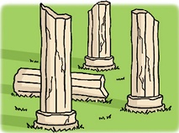
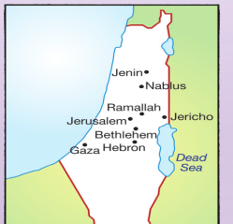



( ) ( ) ( ) ( )

Speaking

1. Complete the following dialogue: {9 marks}

Ahmed: …………old are you ?
Where
Gaza
writing
ten
How
Basel: I'm ………. Years old
Ahmed: ……….. are you from ?
Basel: I'm from ……………
Ahmed: What do you like doing?
Basel: I like ……………. emails.

2. Complete: ( Amy – broke– leg – better –)

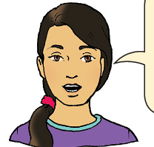


Amy : Rania:
Hi : Rania Hi……………..
How is your …………….? My leg is …………….,thanks?
How did you do that ? I …………..my leg at the football game ?

Reading ( 12)
- Read and answer :
Three friends liked a princess. They wanted to marry her. She asked them for a present dowry. Hassan found a mirror .he could see all the things in it Basim found a rug .he could fly on it and see all things. Murad found an apple. It helped people when they did not feel well.

-----------------------------------------------------------------------------------------
Read and complete : {4 marks}

a-Choose the correct answer :
1- The friends liked ……………..... . [ a girl – a queen – a princess 2-asked them for find ……………… .[ a dowry – a job – a present
3- Hassan found a ………………… [ mirror – ill – sad ]
4- Basim found a……………… [ mirror – rug - apricot ]
5- "it " in line 3 refers to ……. [ apple – palace - a dowry ]

B) Read . Then put( T ) or( F ) :

1- Murad Hassan had a carpet .
2- They flew on the rug .
3- Murad had nothing .
4- They wanted to marry the princess .

C) Answer the questions
1- Where did Basim take his friends ?
……………………………………………………………………………
2- What did Murad give the princess ?
………………………………………………………………………
3- Did the princess marry Hassan ?
………………………………………………………………….
language and structure

Choose the correct answer: - {8 marks}

1- He (wash – washes) his hands every day .
2- Rania is number 10 , she is the (tenth- ninth )
3- June, July and August are in the (spring – summer)
4- The Olympic stadium (is /are).in London.
5- He ( read - is reading ) a story now.
6- The children (were / was ) cold and wore sweaters.
7- Mum is cooking now . ( He - She ) is good at cooking.
8- Did they ( drove /drive ) to Gaza last summer ?
-----------------------------------------------------------------------------------------
Writing

Write correctly: {3 marks} 1-

1-he is from Palestine ……………………………………………………..

2- how old are you ………………………………………………………

-----------------------------------------------------------------------------------------
2-Write:

There are twelve months in the year
____________________________________________________________________________________________________________________________________________________________________________________________________________
GOOD LUCK

مزيد من اختبارات اللغة الانجليزية للصف الخامس من هنا
https://www.wepal.net/library/?app=content.list&level=5&semester=2&subject=5&type=2

