[**اختبار نهاية الفصل الدراسي الثاني للعام 2015 / 2016 م**](https://www.wepal.net/library/?app=content.list&level=5&semester=2&subject=5&type=2)

**دولـــــــــــــــــــــــــــــــــــــــــــــــــة فلســــــــــــــــــــــــــــــــــــــــــــــــــــــــــــــــــــــطين**

**40**

**وزارة الــتــــــــــــربـــــيــــــــــة والـــتــعــــلــيـم الـــعــــالـــــــــــــــــــــــــــــــــي اسم الطالب: .......................**

**مـــديــــريــــــة الـــتـربـــيـــة والــتـعــلـيم-شــــرق خــان يـــونـــس الصف: الخامس صباحي**

**المادة: اللغة الانجليزية**

**1) Listening (5 Marks)**

***1) Listen and number the pictures: -* 5 points**

***[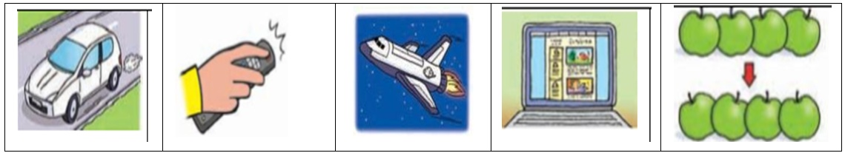](https://www.wepal.net/library/?app=content.list&level=5&semester=2&subject=5&type=2)***

**2) Speaking (11.5 Marks)**

**2) Match :- 2.5 points**

|  |  |
| --- | --- |
| **1-** What are you doing now ? | ( ) My favourit animal isa giraffe . |
| **2-** What did the farmer buy ? | ( ) On the internet . |
| **3-** When did Ben break his leg ? | ( ) I'm reading a story . |
| **4-** Where can you see ablog ? | ( ) He bought a goat . |
| **5-** What's your favourit animal ? | ( ) He broke his leg last summer |

***a) Complete the dialogue :-*  8 points**

**Omar** : Where did you go ………………….. weekend?

animal

do

last

giraffe

did

any

zoo

touched

I went to the ………………………. . **Ben**:

**Omar** : What's your favourite ……………………… ?

B**e**n : My favourite animal is a …………………….. .

**Omar** : What did you ……………….. there?

**Ben** : I…………………. the giraffe .

**Omar** : Did you give it ………………… fruit ?

**Ben** : yes, I ………………… .

***b) What would you say in the following situation*  1 points**

1- When you start a story?

a) In the end b) once upon a time c) I'm sorry

تا**بع خامس صباحي – 2 -**

**3) Reading: (5 Marks)**

***Read the passage then answer the questions:-***

Omar bought a new laptop last summer. It's light but expensive. **It** has screen,

mouse and key board . Omar used it to play games and write his ideas on his blog

***1) True or false :-***

a- Omar bought a new computer. ( )

b-The laptop hasn't any buttons. ( )

**2) Complete :-**

a) Omar's laptop is ………………………….. .

b) Omar used the laptop to ……………………………….

***3) Get from the passage :-***

a) The opposite of: old X …………………... . " heavy" × ………………………..

b) Award rhymes with "house " ……………………… .

c) past of " buy " ……………………………….

d) The underlined " **It** " refers to …………………………… .

e) Do you have a laptop at home? ……………………………………………………….. .

**4) Vocabulary: (6.5 Marks)**

***1- Fill in a space:*** *-* **2.5 points**

try busy move looks for travel

1-The farmer …………………………. the left shoe.

2-On the road the car didn't …………………….. .

3- The market was very ………………………. . They were many people.

4- The family are going to …………………………. by car.

5- Can I …………………….. Your mobile phone ,please ?

***2- Classify the following: -* 4 point**

**olives keyboard bananas hospital screen onions**

**restaurant palace mouse carrots figs potatoes**

**fruit vegetable computer places**

**تابع خامس صباحي – 3 -**

**5) Language (5 Marks)**

[***Choose the correct answer***](https://www.wepal.net/library/?app=content.list&level=5&semester=2&subject=5&type=2)***:-***

1) The wolf laughed ……………..……….. ( on - at – in ) the farmer .

2) The car couldn't………..……………….. ( drive – got – move ) .

3) What………………….. ( does – doing - did ) Omar do yesterday?

4) The children ………………….. ( are – was – were ) at the park last night .

5) We are ……………….……..( use – used -using) a computer now .

**6)** [**Writing (7 Marks)**](https://www.wepal.net/library/?app=content.list&level=5&semester=2&subject=5&type=2)

***Do as shown in the brackets:-*  4 points**

1- ahmeds family drove to nabluse last weekend. ( **Punctuate** )

…………………………………………………………………………………………….…………. .

2- I use Can mobile phone your please ? ( **Re- arrange** )

……………………………………………………………………………………………………….. .

3- Is a laptop heavier than a computer? ( **answer** )

……………………………………………………………………………………………………….. .

4- Amy is going to eating her lunch . …………………….. (**correct** )

**2 points *c) Think of the clues:-***

1) I like to move. I don’t like to sit. What am I? ………………… .

2) I taste like sugar. I'm a plant. What am I? …………………. .

***d)Hand writing :-* 1 point**

**We all wanted to visit Jerusalem.**

**انتهت الأسئلة**

**Listening Textاستماع الخامس صباحي**

***1) Listen and number the picture:-***

1- We will travel to outer space by spaceship .

2-Idon't like these apples . I want those ?

3-The car is moving in the road .

4- We use the remote control to turn on TV .

5- This is Ben's blog.

**Listening Textاستماع الخامس صباحي**

***1) Listen and number the picture :-***

1- We will travel to outer space by spaceship .

2-Idon't like these apples . I want those ?

3-The car is moving in the road .

4- We use the remote control to turn on TV .

5- This is Ben's blog.

مزيد من اختبارات اللغة الانجليزية للصف الخامس من هنا

<https://www.wepal.net/library/?app=content.list&level=5&semester=2&subject=5&type=2>