|  |  |  |
| --- | --- | --- |
| دولة فلسطين  وزارة التربية والتعليم العالي  مديرية التربية والتعليم قلقيلية  ذكور كفر قدوم الاساسية | **pnalogo(2)(11)(1).bmp** | State of Palestine  Ministry of Education and Higher Education  Director of Education/Qalqilya  Kuffer Qadoom basic boy's school |

Grade : 2nd Worksheet ( unit 7 ) Date : \ \ 2015

**Teacher : Tha'er Z. Taha Name:______________________**

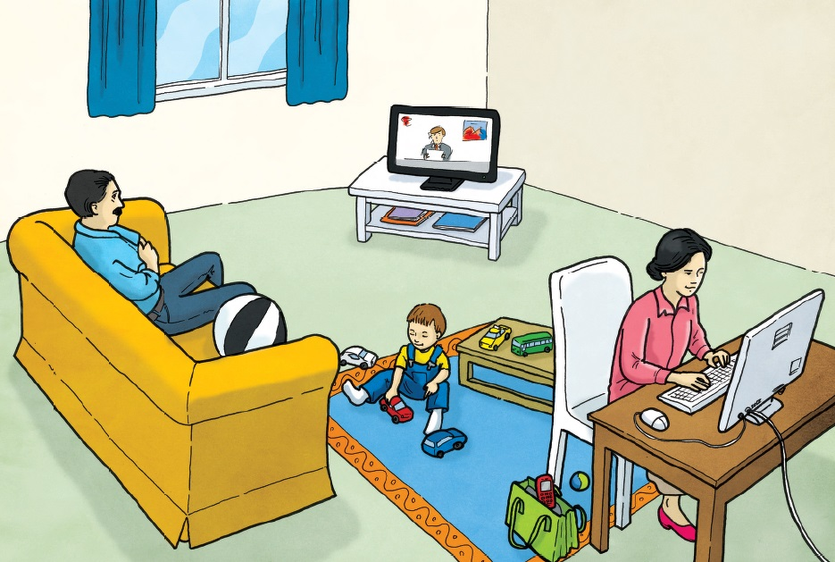

1. **Look and answer.**
2. **The telephone is _____ the bag. B- The ball is _____ the sofa.**

**C- The rug is __________ the chair. D- the computer is _____ the table.**

**2- Trace and write.**

