|  |  |  |
| --- | --- | --- |
| **State of Palestine**  **Ministry Of Education &Higher EducationDirectorate Of Education -Tulkarm**  **Shoufah Mixed School** | **2012/2013** | **دوله فلسطين**  **وزارة التربية والتعليم العالي**  **مديرية التربية والتعليم ـــــ طولكرم**  **مدرسة شوفه ث م**  **الرقم الوطني** |
| **التاريخ: .... \ \ 2013** | **الصف: .............5........** | **المبحث:...............E..............................** |
| **الزمن: حصه** | **الاسم:** | |

1. [**Read and answer 7**](https://www.wepal.net/library/?app=content.list&level=5&semester=2&subject=5&type=2)

**[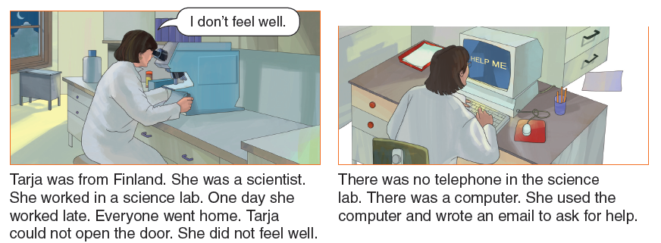](https://www.wepal.net/library/?app=content.list&level=5&semester=2&subject=5&type=2)**

**[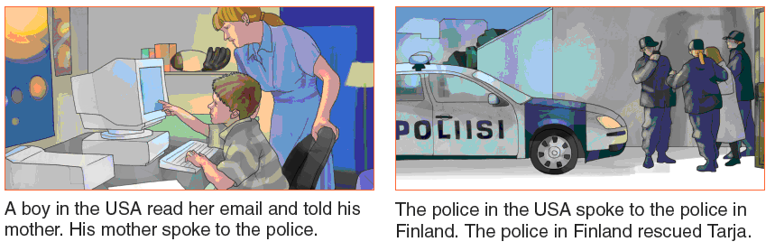](https://www.wepal.net/library/?app=content.list&level=5&semester=2&subject=5&type=2)**

1. **Who rescued Tarja? ----------------------------------------------**
2. **Was there a telephone in the science lab? -----------------------**
3. **Complete**
   * **Tarja used the-------------- and wrote an email.**
4. **Correct**

**Tarja worked in a farming lab.**

1. **Tick**

**Tarja feels very well. □**

1. **Circle**

**The police in Finlandrescued / visitedTarja.**

**7-** *She* **refers to -------------------**

[**Language**](https://www.wepal.net/library/?app=content.list&level=5&semester=2&subject=5&type=2)

1. **Read and circle 3**

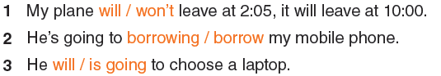

**2-Read and write 5**

**What will happen in the future?**

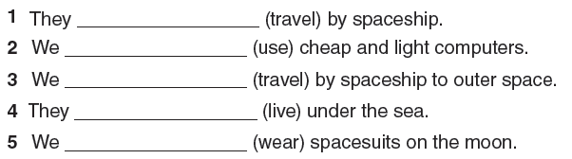

**3-Think and complete 3**

**[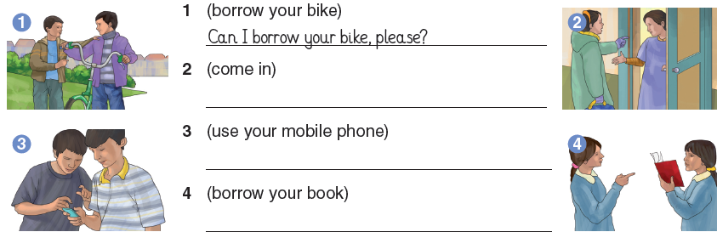](https://www.wepal.net/library/?app=content.list&level=5&semester=2&subject=5&type=2)**

**4-Read and complete 3**

[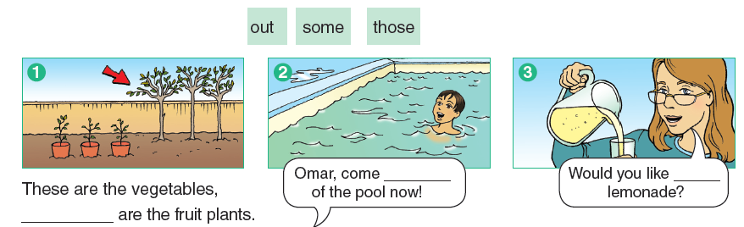](https://www.wepal.net/library/?app=content.list&level=5&semester=2&subject=5&type=2)

**5- Read and tick 4**

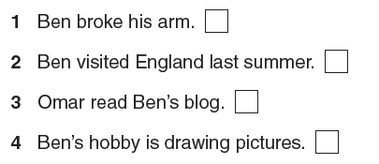

**6- Write correct sentences4**

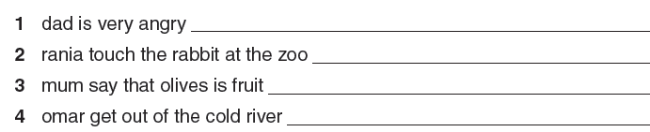

**7- Write and complete3**

|  |
| --- |
| laughed Both happy angry |

[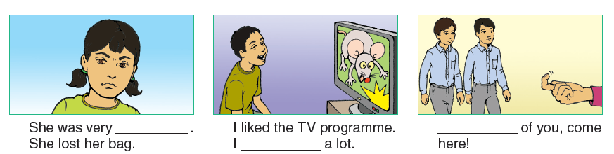](https://www.wepal.net/library/?app=content.list&level=5&semester=2&subject=5&type=2)

**8- Think and write 4**

What happened yesterday?

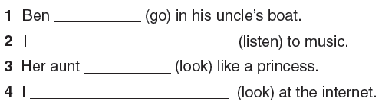

**9- Listen and match4**

[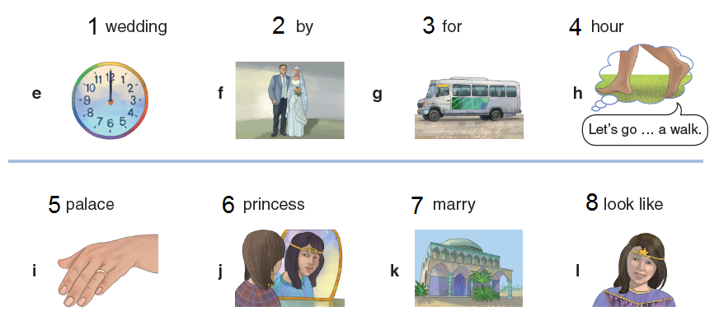](https://www.wepal.net/library/?app=content.list&level=5&semester=2&subject=5&type=2)

1. **Listen and circle 4**

[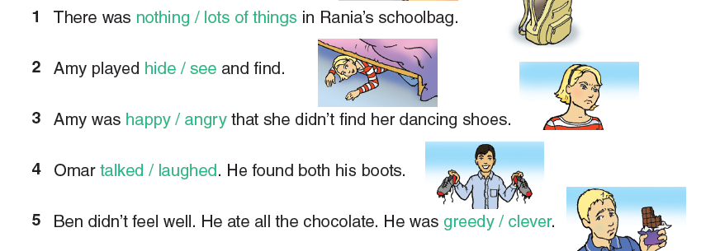](https://www.wepal.net/library/?app=content.list&level=5&semester=2&subject=5&type=2)

1. **Listen and choose 4**

[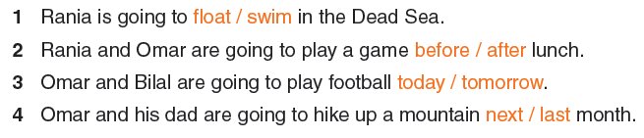](https://www.wepal.net/library/?app=content.list&level=5&semester=2&subject=5&type=2)

**12-Answer the questions 2**

[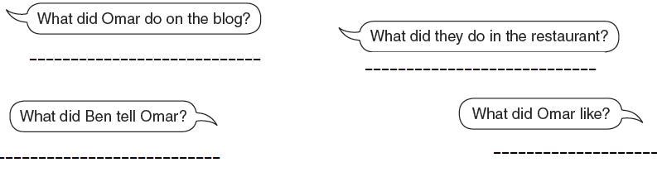](https://www.wepal.net/library/?app=content.list&level=5&semester=2&subject=5&type=2)

مزيد من اختبارات اللغة الانجليزية للصف الخامس من هنا

<https://www.wepal.net/library/?app=content.list&level=5&semester=2&subject=5&type=2>