|  |  |  |
| --- | --- | --- |
| **Palestine State**  **Ministry of Education**  **Directorate of Tulkarm**  **Nazlat Issa Basic Boys' School** |  | **Name:**  [**Class:1st Grade**](https://www.wepal.net/library/?app=content.list&level=1&semester=1&subject=5&type=2&submit=submit)  **Date:** |

**U--1**

[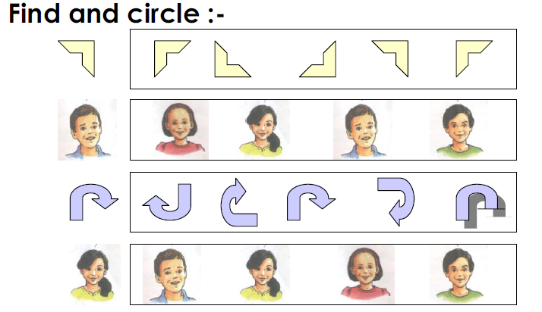](https://www.wepal.net/library/?app=content.list&level=1&semester=1&subject=5&type=2&submit=submit)

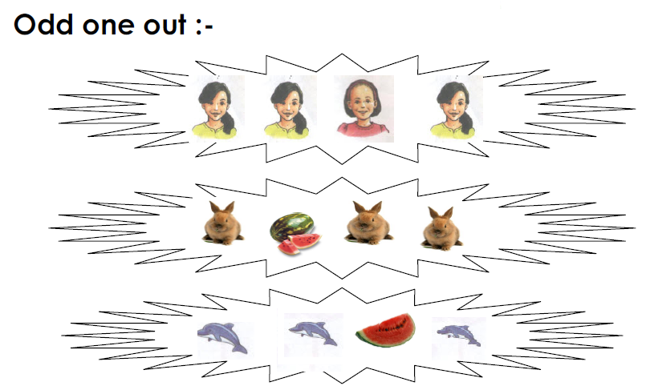

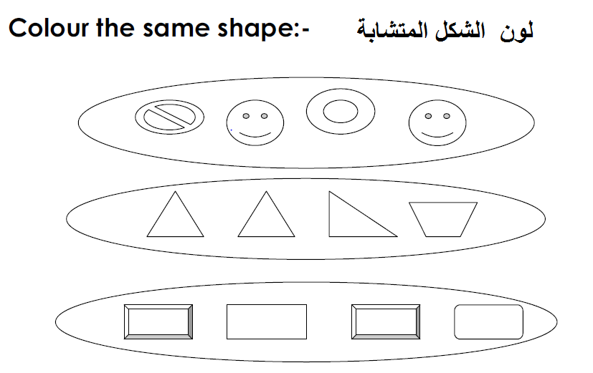

[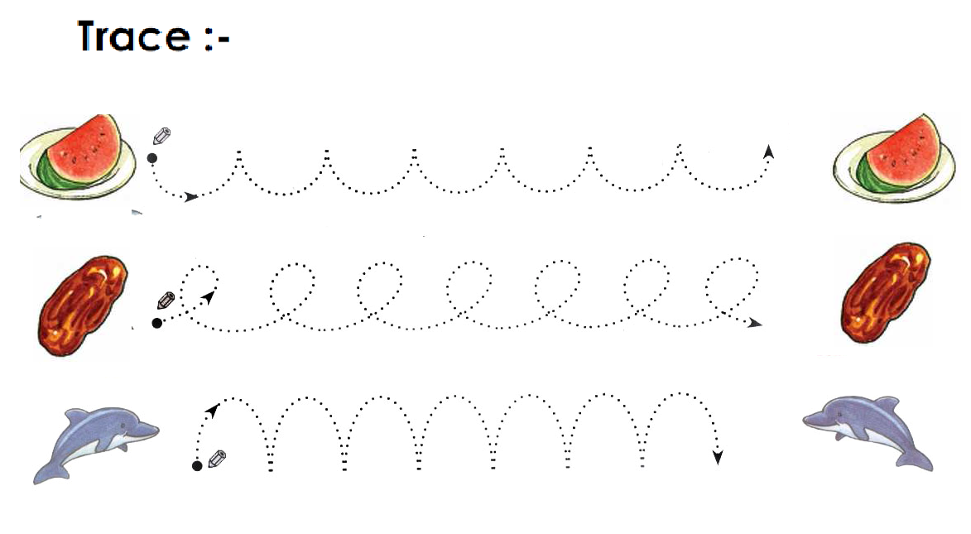](https://www.wepal.net/library/?app=content.list&level=1&semester=1&subject=5&type=2&submit=submit)

**********************************************************************************************************

The End T. Akram Younis Good Luck