|  |  |  |
| --- | --- | --- |
| **Name:**  **Class:**[**4th Grade**](https://www.wepal.net/library/?app=content.list&level=4&semester=1&subject=5&type=2&submit=submit)  **Date:** | **[فلسطين](https://www.wepal.net/library/?app=content.list&level=4&semester=1&subject=5&type=2&submit=submit)**  **الفصل الدراسي الأول**  **2020/2021م** | **Palestine State**  **Ministry of Education**  **Directorate of Tulkarm**  **Nazlat Issa Basic Boys' School** |

**1- Complete the dialogue:**

**(melon - Good afternoon - 10 - desert - Beth)**

**Fiona: Good afternoon------------------**

**Beth: ----------------------------------- Fiona.**

**Fiona: What do you like for --------------?**

**Beth: I'd like ------------------------ ice cream, please.**

**Fiona: The bill is ---------dinars.**

-----------------------------------------------------------------------------------------

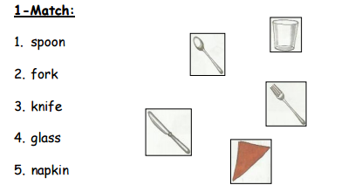

------------------------------------------------------------------------------------------------

**2-Complete the missing letters:**

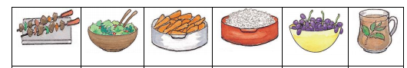

**Me…t S…lad Car…ot Ric… Gra…pe t…a**

**-Choose:**

**1. Could I ………….…. a pen? (have – has - like)**

**2. Tom has …………….……to drink. (water – chicken – kunafeh)**

**3. Mum …………………have kunafeh. (don't – doesn't - isn't)**

**4. Beth asks ……………a knife. (for – on – at)**

**5. I'd ……………….... fish, please. (bike – like – have)**

………………………………………………………………………………………………………….

**-Classify:**

**(chicken – lemonade – meat – ice cream – juice – kunafeh – thirty –**

**knife – napkin –hundred)**

[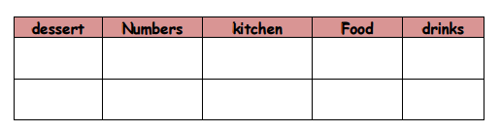](https://www.wepal.net/library/?app=content.list&level=4&semester=1&subject=5&type=2&submit=submit)

---------------------------------------------------------------------------------------------------

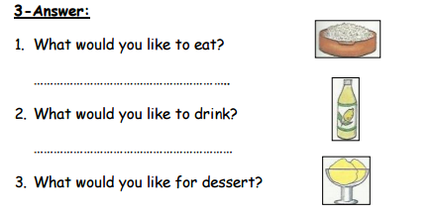

**----------------------------------------------------------------------------------------------**

The End T. Akram Younis Good Luck