**[4](https://www.wepal.net/library/?app=content.list&level=4&semester=2&subject=5&type=2)[th](https://www.wepal.net/library/?app=content.list&level=4&semester=2&subject=5&type=2) [Grade Final Exam Second Semester](https://www.wepal.net/library/?app=content.list&level=4&semester=2&subject=5&type=2)**

**1. Listen and match.**

|  |  |  |  |
| --- | --- | --- | --- |
| **1** | Jamal | ........ | helped his aunt with the donkeys |
| **2** | Hala and Bilal | ........ | helped his uncle with the sheep |
| **3** | Walid | ........ | collected the eggs |
| **4** | Fiona and Nour | ......... | watched the ducks |

**2. Listen and put ( ) or ( X) .**

**[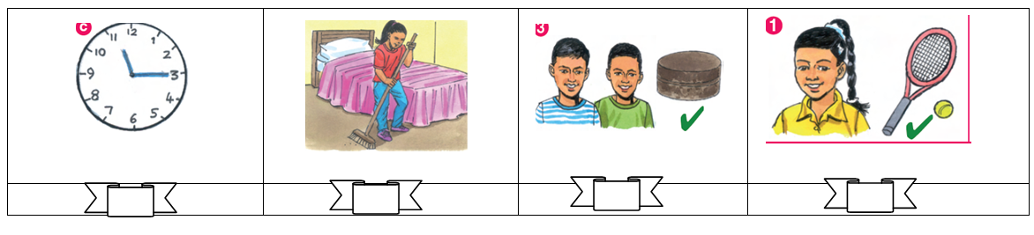](https://www.wepal.net/library/?app=content.list&level=4&semester=2&subject=5&type=2)**

**3. Listen and circle.**

1. In Britain school starts at **8:30** **/ 8:45.**
2. Fiona liked the **flowers** / **butterflies**.
3. I **never** /**sometimes** do my homework at night.
4. Hala adds **one** / **two** spoons of nuts.

__________________________________________________________________________

**4. Complete the dialogue.**

Brush – Friday – do - see

1. What are we going to do on _________________ ?
2. I am going to __________________ Al-Aqsa Mosque.
3. Do you _____________ your teeth in the morning?
4. Yes, I ___________

**[](https://www.wepal.net/library/?app=content.list&level=4&semester=2&subject=5&type=2)5. Choose.**

Fiona’s family is going to visit ........

**a. Haifa**

**b. Hebron**

**c. Bethlehem**

**6.** [**Choose the correct answer**](https://www.wepal.net/library/?app=content.list&level=4&semester=2&subject=5&type=2)**.**

1. To make a cake we need { **flour** – **chicken** – **tomatoes** }
2. There are donkeys. There { **is** – **aren’t** – **are** } sheep.
3. 10 + 10 + 10 + 5 = { **twenty-five** – **thirty-five** – **forty-five** }
4. The baker’s is on the { **left** – **between** – **milk** }

[](https://www.wepal.net/library/?app=content.list&level=4&semester=2&subject=5&type=2)**6. Match with pictures.**

1. I can speak Arabic.

2. He can’t build a snowman.

3. I bought bananas.

4. He bought bread.

**7. Correct the underlined mistakes.**

1. He always **clean** his bedroom. ( _______________)
2. How **much** eggs? 6 eggs. ( _______________)
3. **In** Monday we are going to visit Jerusalem. ( __________ )

**8. Complete.**

going

1. Bilal is _____________ to visit Haifa.

six

ride

1. I can____________ a bike.
2. We need __________ cups of milk.

**8. Look and write.**

**[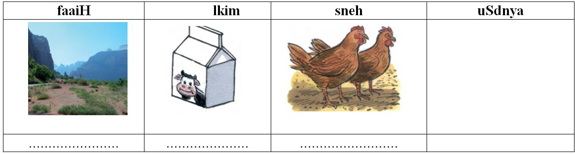](https://www.wepal.net/library/?app=content.list&level=4&semester=2&subject=5&type=2)**

**9. Write.**

1. dance / dabka / we / can ___________________________________________________

**10. Classify.**

|  |  |  |
| --- | --- | --- |
| **Cities المدن** | **Habitsالعادات** | **Hebron get up**  **Brush Bethlehem**  **Jerusalem wash** |
|  |  |
|  |  |
|  |  |

**12. Copy**

**I sometimes get up early**

للمزيد من امتحانات اللغة الانجليزية للصف الرابع الفصل الثاني

<https://www.wepal.net/library/?app=content.list&level=4&semester=2&subject=5&type=2>

***Listening Material***

***1. Listen and match***

1. *Hamzah always brushes his teeth*
2. *Fiona never helps her mum*
3. *Walid sometimes brushes the dishes*
4. *Hala never gets up late.*

***2. Listen and put (T ) or (X)***

1. *What’s the time? It’s nine o’clock. (X)*
2. *Fiona always cleans her bedroom. (X)*
3. *Hamzah can run. ( T )*
4. *Walid can’t swim in the sea. ( X )*

***3. Listen and circle.***

1. *In Palestine school starts at 700*
2. *Hala liked the giraffes*
3. *I always do my homework*
4. *Hala puts one cup of flour*