[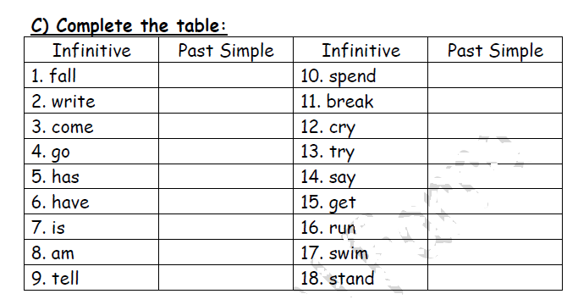](https://www.wepal.net/library/?app=content.list&level=6&semester=1&subject=5&type=2&submit=submit)

