|  |  |  |
| --- | --- | --- |
| Subject [: English](https://www.wepal.net/library/?app=content.list&level=5&semester=2&subject=5&type=2)  Grade [: 5th grade](https://www.wepal.net/library/?app=content.list&level=5&semester=2&subject=5&type=2)  Time : One hour  Date :  Name: ……..…...................... | بسم الله الرحمن الرحيم  [امتحان نهائي الفصل الثاني](https://www.wepal.net/library/?app=content.list&level=5&semester=2&subject=5&type=2) | State of Palestine  Ministry of Education  Directorate Of Education / Tulkarm |

**Listening**

**Listen and circle the correct words: - {8 marks}**

1- This is **a photo / drawing** of London.

2- There are a lot of old **schools / buildings**

3- Reem is **seventh / sixth** in the race

4- In **September / March** you can collect banana

-----------------------------------------------------------------------------------------

**2- Listen and number the pictures**

**[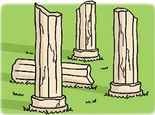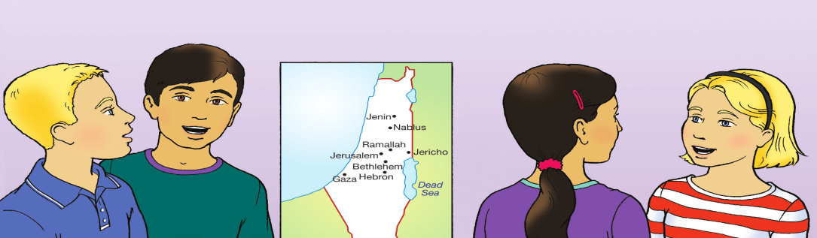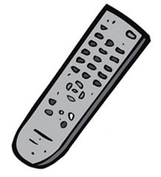](https://www.wepal.net/library/?app=content.list&level=5&semester=2&subject=5&type=2)**

**( ) ( ) ( ) ( )**

**Speaking**

**1. Complete the following dialogue: {9 marks}**

Ahmed: …………old are you ?

**Where**

**Gaza**

**writing**

**ten**

**How**

Basel: I'm ………. Years old

Ahmed: ……….. are you from ?

Basel: I'm from ……………

Ahmed: What do you like doing?

Basel: I like ……………. emails.

2. **Complete**: ( Amy – broke– leg – better –)

[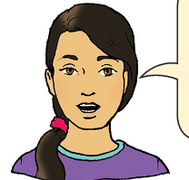](https://www.wepal.net/library/?app=content.list&level=5&semester=2&subject=5&type=2)

Amy : Rania:

Hi : Rania Hi……………..

How is your …………….? My leg is …………….,thanks?

How did you do that ? I …………..my leg at the football game ?

**Reading ( 12)**

1. **Read and answer :**

Three friends liked a princess. They wanted to marry her. She asked them for a present dowry. Hassan found a mirror .he could see all the things in it Basim found a rug .he could fly on it and see all things. Murad found an apple. **It** helped people when they did not feel well.

-----------------------------------------------------------------------------------------

**Read and complete : {4 marks}**

**a-Choose the correct answer** :

**1-** The friends liked ……………..... . [ a girl – a queen – a princess 2-asked them for find ……………… .[ a dowry – a job – a present

**3-** Hassan found a ………………… [ mirror – ill – sad ]

**4**- Basim found a……………… [ mirror – rug - apricot ]

**5**- "**it** " in line 3 refers to ……. [ apple – palace - a dowry ]

**B) Read . Then put( T ) or( F ) :**

**1**- Murad Hassan had a carpet .

**2**- They flew on the rug .

**3**- Murad had nothing .

**4**- They wanted to marry the princess .

**C) Answer the questions**

**1-** Where did Basim take his friends ?

……………………………………………………………………………

**2-** What did Murad give the princess ?

………………………………………………………………………

**3-** Did the princess marry Hassan ?

………………………………………………………………….

[**language and structure**](https://www.wepal.net/library/?app=content.list&level=5&semester=2&subject=5&type=2)

**Choose the correct answer: - {8 marks}**

1- He **(wash – washes)** his hands every day .

2- Rania is number 10 , she is the **(tenth- ninth )**

3- June, July and August are in the **(spring – summer)**

4- The Olympic stadium **(is /are)**.in London.

5- He ( **read - is reading** ) a story now.

6- The children (**were / was** ) cold and wore sweaters.

7- Mum is cooking now . ( **He - She** ) is good at cooking.

8- Did they ( **drove /drive** ) to Gaza last summer ?

-----------------------------------------------------------------------------------------

**Writing**

**Write correctly: {3 marks} 1-**

1-he is from Palestine ……………………………………………………..

2- how old are you ………………………………………………………

-----------------------------------------------------------------------------------------

**2-Write:**

**There are twelve months in the year**

____________________________________________________________________________________________________________________________________________________________________________________________________________

**GOOD LUCK**

مزيد من اختبارات اللغة الانجليزية للصف الخامس من هنا

<https://www.wepal.net/library/?app=content.list&level=5&semester=2&subject=5&type=2>