|  |  |  |
| --- | --- | --- |
| **Name:**  **Class:** [**1thGrade**](https://www.wepal.net/library/?app=content.list&level=1&semester=1&subject=5&type=2&submit=submit)  **Time:**  **Date:** | **[فلسطين](https://www.wepal.net/library/?app=content.list&level=1&semester=1&subject=5&type=2&submit=submit)** | **Palestine State**  **Ministry of Education**  **Directorate of Tulkarem**  **Nazlet Issa Secondary Boys' School** |

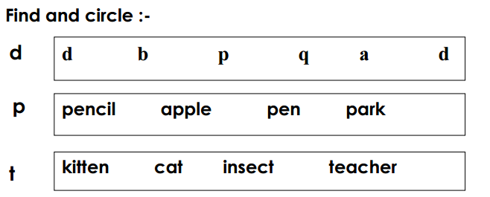

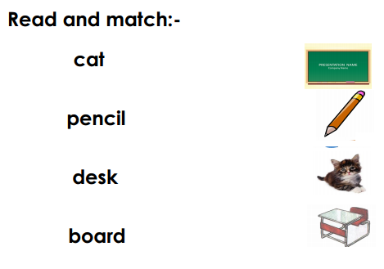

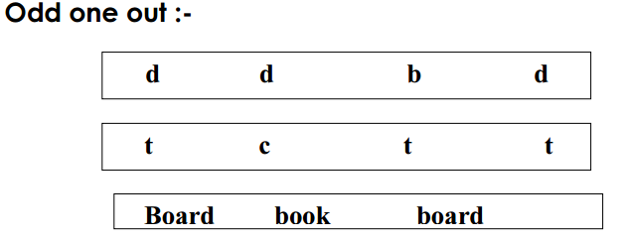

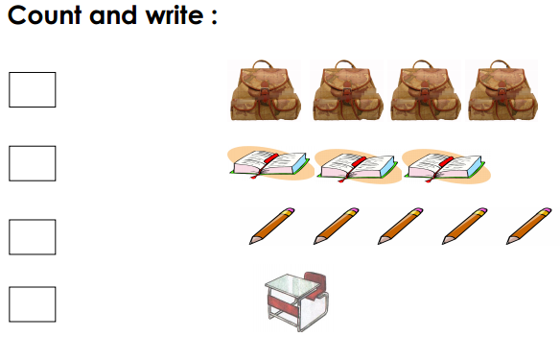

[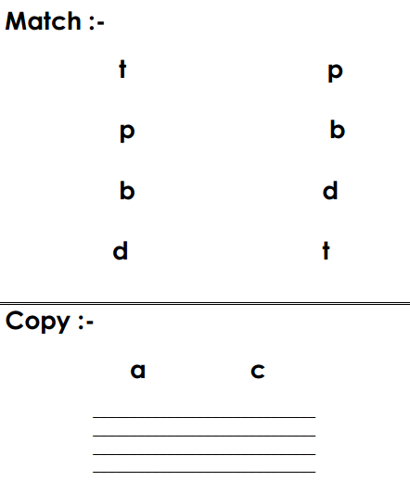](https://www.wepal.net/library/?app=content.list&level=1&semester=1&subject=5&type=2&submit=submit)

**The End**

**T. Akram Younis Good Luck**