|  |  |  |
| --- | --- | --- |
| **Ministry of Education& Higher Education**  **Directorate of Khan-yunis**  **Time: An hour and half**  **Date: / 1 / 2017** | **الإجابة النموذجية لامتحان الصف الخامس الأساسي الفترة الصباحية مجموع العلامات40 /علامة** | **دولة فلسطين**  **وزارة التربية والتعليم العالي**  **مديرية التربية والتعليم خان يونس** |

**(4 Marks) I-Listening**

**1-Listen and circle: (2 points)**

a- I go (**hiking** - walking) in the valley.

b- There is a swimming (game - **race**).

**2-Listen and number the pictures: (2 points)**



**2**

**4**

**1**

**3**

**(6 Marks) II-Speaking**

**3-Match the part A with suitable from part B: (2 points)**

|  |  |  |
| --- | --- | --- |
| **(B)** |  | **(A)** |
| Everyone can play Basketball. | ( d) | a- What is Ben showing Omar? |
| In June, July and August. | ( c ) | b- Is Rania running in the 200-metre race? |
| No, She isn’t. | ( b ) | c-When is the summer holiday? |
| The Olympic stadium. | ( a) | ?d-Who can play Basketball |

**4-Complete thefollowing dialogue:(4 points)**

|  |
| --- |
| **Hello - metre - Adnan - Omar** |

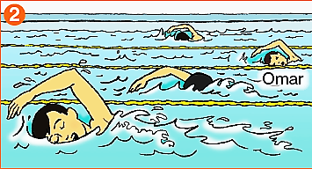

Ali : Hello**Adnan**

Adnan : **Hello**Ali.

Ali : Who are swimming in the 50**metre**race?

Adnan : **Omar** and his friends.

**(8 Marks) III-Reading**

**5-Read the passage then answer the question:**

Omar looks at a picture of Ben's dad. He is in a walking race. **His** mum helps his dad. She has a bottle of water in her hand. Rania, Ben and Omar talk about what they like doing. Rania likes looking at cats on the internet. Omar and Ben both like watching film at the cinema. Ben likes writing emails.

**A)Answer the following question: (1 points)**

a- Who likes writing emails?

**Ben likes writing emails.**

**B) Put (T) or (F):(4 points)**

a- Ben's dad is in the running race. ( **F** )

b- Omar looks at a picture of Ben's mum. ( **F** )

c- Rania, Ben and Omar talk about what they like doing. ( **T** )

d- Rania likes looking at dogs. ( **F** )

**C) Find in the passage:(3 points)**

a- A name of drink **water**animal **cats**

b-The underlined words **(His)** refers to (Omar – **Ben**)

**(8 Marks) IV-Vocabulary**

**6-Complete the sentences from words in the box:(4points)**

|  |
| --- |
| **news – windy – third - clever** |

a-It is **windy**in October.

b-Dwight Howard is **clever**at playing basketball.

c-I can read the **news** in the newspaper.

d- Monday is the **third** day of the week.

**7-Write the words under the pictures: (4points)**

|  |
| --- |
| **hopping – races – fat - hiking** |

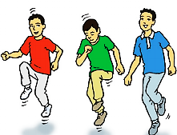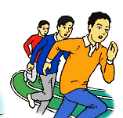

**1-races 2-hiking3-hopping 4-fat**

**(8 Marks) VI-Language**

**8-Choose the correct answer: (4points)**

a- She (**doesn’t** – don’t) have parents.

b- I (**have** – has) five sisters.

c- We (**write** - writes) our homework **every day.**

d- The girls are (stand - **standing**) in the class **now.**

**9-Correct the underlined mistakes: (4 points)**

a- Rania is (**younger**). (young)

b- The sea is **(wide**) than the river. (wider)

c- English is the **(difficult)** exam. (most difficult)

d- The bird is **(beautiful)** than the bee. (more beautiful)

**(6 Marks) V-Writing**

**10-Re –arrange the words to make correct sentences:(1point)**

a- ninth - is - Ali - in - the - race - hopping .

**Ali is ninth in the hopping race.**

**11–Write correct sentences using (and):(2 points)**

a- He likes tennis. He likes Basketball.

**He likes tennis and Basketball.**

b- I can speak English. I can speak Arabic.

**I can speak English and Arabic.**

**12-Copy the following sentence:(3points)**

We love English Language

**With my best wishes**