

State of Palestine

Ministry of Education

Directorate of Jenin

QuadoraMussaBasicSchool

English Language

thGrade6

**Daily Exam(45pts)**

**Time:40mts Date:23/11/ 2014**

***Student Name: ------------------ Sunday***

***I-Listening***

***1Listen and circle the word you hear:***

1- should – shouldn't- could – couldn't.

2- soup – soap – top – good .

3- eat – meat – ate – sweet.

4- me – my – mine – may.

5- ( Burgers – vegetable soup ) is a healthy food .

**II-Reading**

**1-Read the passage then answer the questions:**

**The top of the food pyramid shows you the food you should eat sometimes, this food like fried food, fizzy drinks and burgers, this food is not healthy. The bottom of the food pyramid shows you the food you should eat always, this food like vegetable soup, meat, rice and water. That's a good advice. So we shouldn't buy fizzy drinks and ice-cream because they're very sweet.**

**A) Answer the questions**

1- What food you can find at the top of the food pyramid?

……………………………………………………………………………………

2- Why shouldn't we eat lots of ice-cream?

……………………………………………………………………………………

**B)Get from the passage:**

1- two **present** verbs ……………………, ……………………..

2- the **opposite** of : a- top…………………… b- bad…………………

C)**Use "should" or "shouldn't":**

1- eat/ lots of/ fried food.

……………………………………………………………………………………………………………………………

2- drink/ fizzy drinks.

……………………………………………………………………………………………………………………………

3- eat/ fruit and vegetables.

……………………………………………………………………………………………………………………………

**D-Fill in the spaces with words from the box**:

|  |
| --- |
| vegetables- fried- healthy – soup – sweet |

1-I should eat lots of…………………….. food.

2- Rania and Omar should eat lots of fruit and ……………………..

3- Fizzy drinks are very ………………………..

3- You shouldn't eat lots of ……………..food.

4- Vegetable …………….. is good for you.

**E- Correct the verb:**

1. The weather ...... nice in Palestine . ( **be** )
2. Not all people ................... healthy food . ( **prefer**)
3. She ............... 1 brother. **( have**)

**F- Choose the correct VERB:**

**1**- I ........................ like pizza**. ( am / do / don’t )**

2- She .......................... happy. **( isn’t / doesn’t / is be )**

3-They ............................ in the garden**. ( are / be / do )**

***VI Writing***

**1-Write the words under the pictures**

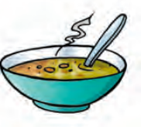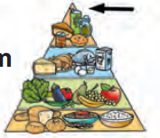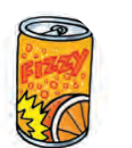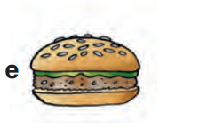

…………… ……………….. …………… ................. 1- soup 2- burger 3- fizzy drink 4- food pyramid

**2- Write 2 sentences about the foods in the pictures above:**

1...................................................................................................................

2....................................................................................................................

3-**Join the sentences with "because**":

- Rice and meat are good for you, they make you strong.

……………………………………………………………………………………………………………………………**-**

**V Speaking**

**4-Match questions from part (A) with suitable replies from part (B) :**

|  |  |  |
| --- | --- | --- |
| **( A )** |  | **( B )** |
| a- What food should you eat lots of ? | ( ) | They are very sweet . |
| b- Why should you not eat lots of fried food ? | ( ) | Healthy and unhealthy food . |
| c- What does a food pyramid show ? | ( ) | vegetables and fruit . |
| d- Why shouldn’t you drink lots of fizzy drink ? | ( ) | Because they make you fat . |

GOOD LUCK