** U---1**

**Name:**

[**Class:4th Grade**](https://www.wepal.net/library/?app=content.list&level=4&semester=1&subject=5&type=2&submit=submit)

**Time:**

**Date:**

**-------------------------------------------------------------------------**

**Palestine State**

**Ministry of Education**

**Directorate of Tulkarem**

**Nazlet Issa Basic Boys' School**

**1-Read the paragraph and answer:**

**I'm Fiona . I'm nine. I'm from London.**

**I have one brother and one sister.**

**2-Choose the right answer:**

**1. She's ……………….(Flona – Fiona)**

**2. She's from…………….(London – Nablus)**

**3. She's ………………(9-8).**

**4. She has …………..brother. ( 1 – 2)**

-------------------------------------------------------------------------------------

**6-Odd one out:**

**1. Mum – dad – Nablus – aunt.**

**2. Oxford- yellow – London – Ramallah.**

**3. reading – swimming – dancing – green**

**4. brother- two – nine – one**

**5. doctor - uncle – driver – nurse**

**6. what - how – where – my**

[**7-Complete the missing letter:**](https://www.wepal.net/library/?app=content.list&level=4&semester=1&subject=5&type=2&submit=submit)

**(e - u – a – i )**

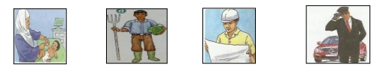

**n_rse f_rmer _ngineer dr_ver**

----------------------------------------------------------------------------------------

[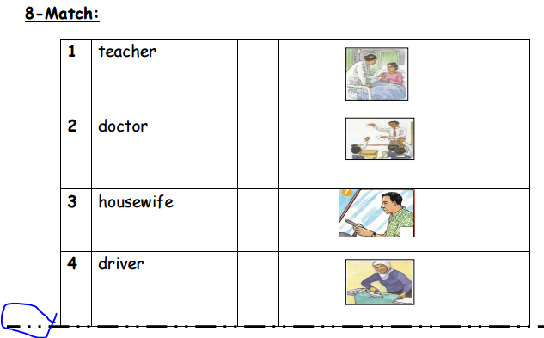](https://www.wepal.net/library/?app=content.list&level=4&semester=1&subject=5&type=2&submit=submit) 