السلطــة الوطنية الفلسطينيــة  وزارة التربية والتعليم العالي  مديرية التربية والتعليم / خان يونس  مدرسة الشهيد عبد العزيز الرنتيسي |  | Palestinian National Authority  Ministry of Education & Higher Education  Directorate of Education\ Khanyounis

Mid Term Exam For 4th Grade
Name:……………………………. Class 4th /……….
A) LISTENING

1- Listen and circle: {2marks }
a- mix add put
b- eleven ten twelve
c- Haifa Gaza Hebron
d- milk sugar Butter
----------------------------------------------------------------------------------------------------------
B)SPEAKING
2- Match A with B: { 4 marks }

A B
I always clean pictures
I play my bedroom
She sometimes brushes music
We draw Her hair

-----------------------------------------------------------------------------------------------------------
C) Reading
3- Read and Match: { 5marks }

1-I get up .
2- I do my homework .

3- I brush my hair.
4- I wash my hands.

5-I clean the table.

4- Circle the correct word: { 3marks }

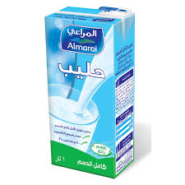 | 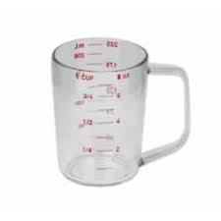 | 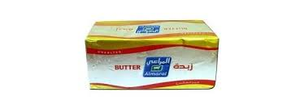
cheese | Bowl | Butter
milk | Cup | Eggs
Cake | Fork | Bread
----------------------------------------------------------------------------------------------------------
D) Writing
5- Order and write : { 1marks }
1 –finishes–it– fifteen– at – six
……………………………………………………………………………
2-She – face – wash –her – always.
……………………………………………………………………………..
-----------------------------------------------------------------------------------------
6- What is the time : { 3marks }

It's………………… It's ………………. It's ………………

------------------------------------------------------------------------------------------------------

7-Hand writing : { 2marks }
How many eggs do we need ?

……………………………………………………………………………………………………………………………………………………………………………………………………………………………………………………………………………………………………………………………………………………………………………………………………………………………………………………………………………………………………………………………………………………………… ………………………………………………………………………………………………………………………………………………………………………………………………………………………………………..……………………………………
………………………………………………………………………………………………………………………………………………………………………………………………………………………………………………………………………………

Good Luck

