|  |  |  |
| --- | --- | --- |
| **________________________Name :** |  | **PalestineٍState of** |
| **Class: 5th ( A -- B -- C )** | **Ministry of Education & Higher Education** |
| **Date : 22 \ 11 \ 2016** | **Directorate of Education /Southern Hebron** |
| **------** | **Al-Farouq Boys Basic School** |
| **د\\\ؤفمغ ...الاسم:..................................................** |  |  |

**1*- Read and answer*  *:***

The season of autumn is windy .The months of September,October , and November are in Autumn . We can fly our kites in October .Amy and Rania look at the internet .They look at the Spring flowers . Spring is in the months of March, April and May .

***1-Read and write ( ) or ( X***

1-- The season of autumn is very hot . ( )

2- Amy and Rania can fly a kite in autumn . ( )

3- They look at the spring flowers in spring . ( )

***2- Complete .***

a-September , October and ----------------- are in -----------

b- We can fly our kites in ------------------.

**3- Answer .**

1- When's Spring ?

-----------------------------------------------------------------------------

2-What can we do in October ?

-----------------------------------------------------------------------------

3-Why does Omer fly his kite in Autumn ?

-----------------------------------------------------------------------------

***3- Choose and complete***

|  |
| --- |
| October year winter summer |

1-June ,July and August are months of ------------------.

2- In --------------------we pick olives .

3- There are twelve months in the ------------------

4- The -----------------months are December , January and February.

**4- W rite**

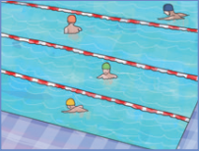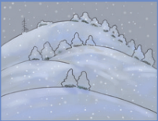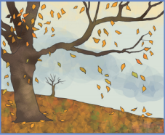

atmunu 2- wr ntei 3- msmure

_________ _________ __________

***5- Read and answer .***

***What do you do every day ?***

1-- I --------------------( wash ) my hands .

2- I------------------(-make ) my bed .

***What does she do every day?***

3- She ---------------( go ) to school .

4- She --------------( clean ) her bedroom .

**6- Choose :**

1- We like summer ( or - and ) autumn .

2- It is snowy ( in -on ) December .

3- February has ( 30 - 28 ) days .

4- Omar can ( pick - picking ) olives in October .

5- Everyday I ( wash - washes ) my head

6- She ( ride - rides ) her bike every day .

**7- Copy .**

January February March April

----------------------------------------------------------------------------------------------------------------------------------------------------------------------------------------------------------------------------------------------------------------------------------------------------------------------------------------------------------------------------------------------------------------------------------------------------------------------------------------------------------------

Teacher

Talal Meawei