School :Nashat Abo Jbara Basic school
Grade :Three Worksheet unit ( 1 ) Date : 17\9\2015 Teacher :Muna Barhoush Name :-----------------
Match 1
1-How old are you? a - I'm from Tulkarm.
2-Where are you from ? - b- I'm ten .
3-What's your name ? - c-I'm fine.
4- How are you? - d-My name's Nour .

2-Read and write
She 's He's her his

------------name's Walid . ----------------name's Hala .
-----------from Bethlehem . ----------------from Bethlehem too.
3-Read Look and coulor

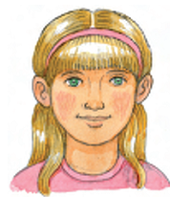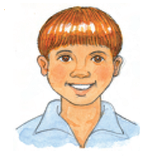
1-She has blonde hair 2- He has red hair
and green eyes . and blue eyes .

