State of Palestine Grade : Two
Ministry of Education & Higher Education Work sheet U. 8
Directorate of Education/ Jenin Date : /12/2014
Al Hashimiya Secondary Girls School Time : 10.m
==================================================================================================== Aims:To complete the sentences with the correct word .To write where people are .To write the correct preposition .To practice handwriting the letters V v / W w / X x .
******************************************************************************************************
1- Let’s look and write :
playground - house - park - school - church - next to - between

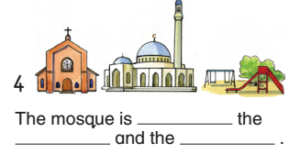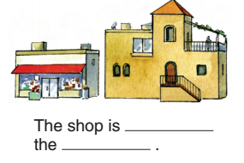
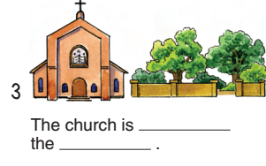

2- Write :
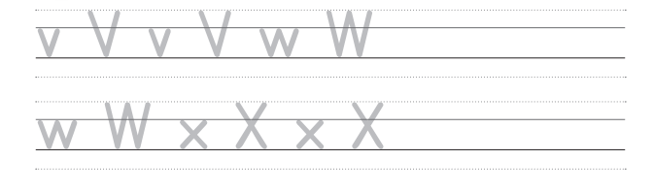

3- Look and write :
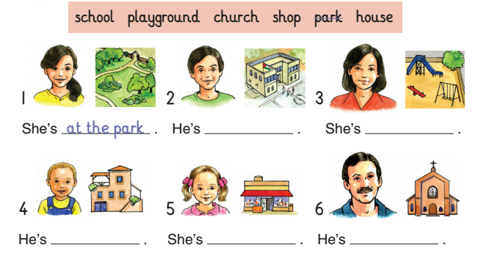
4- Write :
in - on - under - between - next to

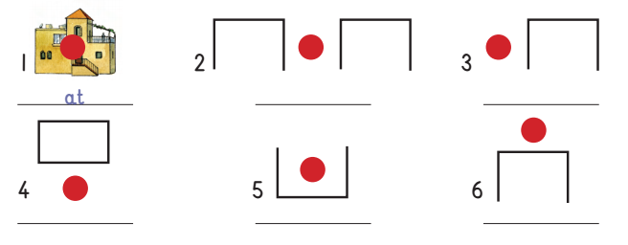
Good luck

