2nd Grade 2014 تقييم أداء نصف الفصل الأول الصف الثاني لغة انجليزية
Name : ……………………….. units:1,2,3&4 Mark: ………………………..

- Listen and number (5m) :-استمع ورقم

- Complete ( 5m ):- ( old- Goodbye-salad-morning-name)أكمل الحوار

Good morning |  | Good …………….
What's your ………..? |  | My name's Amir
How …….. are you ? |  | I'm 7
What do you like? |  | I like ………….
Goodbye ,Amir. |  | ……………. ,Sami.

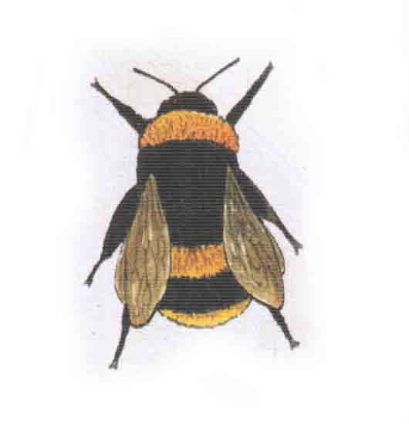
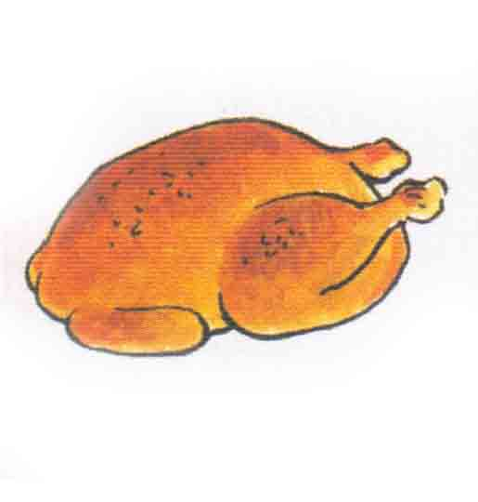
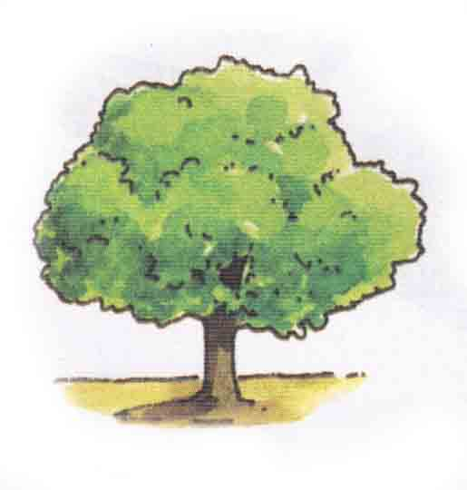
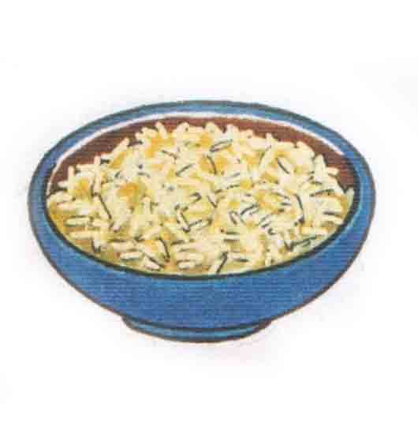
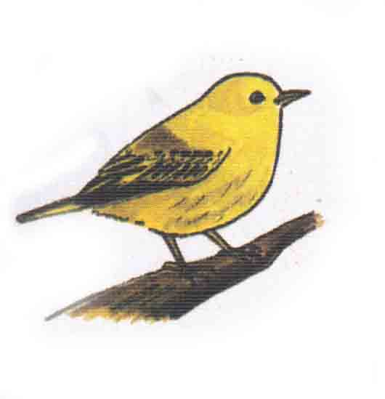
- Choose ( 5m ):-اختر
bird | fish | bee | flower | rice
bee | chicken | butterfly | tree | meat

- Re-arrange (3m ):- رتب
- Chicken. \ I \ like ……………………………………..
- likes\ meat.\ She ……………………………………………

- Copy (2m):- Adam likes fish. اكتب بخط جميل

