
السلطة الوطنية الفلسطينية
وزارة التربية والتعليم الاسم: ...................
مديرية التربية والتعليم العالي الصف: الرابع أ+ب
مدرسة التاريخ: .................

1) Listening
Listen and tick ( ) :
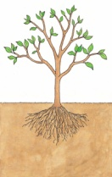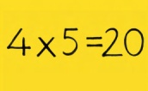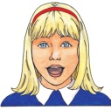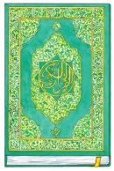

2 ) Read and circle
1. In maths / religion we learn about numbers.

2. In Arabic / science we learn about animals, flowers and trees.

3. In English / science we sing songs.

4. In religion / PE we learn about Islam.

5. In Arabic / maths we read stories.

3) Speaking
maths

science and religion

go to the mosque

play football

1. A) What subjects do you have on Mondays ?

B) I have …………….

2. A) What's your favourite subject ?

B) My Favoutite subject is …………..

3. A) Waht do you do at the weekend ?
B) On Fridays I …………………………

On Saturdays I ……………………...

4. Writing
Re-arrange :

1. Fridays / I / music / listen / to / On

2. games / On / I / computer / Saturdays / play

Re-arrange :
niolergi EP sneecci

……………. ……………. ………………

