السلطة الوطنية الفلسطينية  وزارة التربية والتعليم العالي  مديرية التربية والتعليم/طولكرم  مدرسة بنات نشأت أبو جبارة |  | Palestinian National Authority  Ministry of Education and Higher Education  Director of Education/Tulkarm  Nash' at Abu Jbarah

Grade :Five Daily Exam ( unit 4 ) Date : 6\ 11 \2015
1- Read and answer Teacher :Muna Barhoush:
The season of Autumn is windy .The months of September,October ,and November are in Autumn .We can fly our kites in October .Amy and Rania look at the internet .They look at the Spring flowers . Spring is in the months of March,April and May .
1-Read and write ( ) or ( X ).
a- The season of Autumn is rainy . ( ).
2-Amy and Rania look at the TV . ( ) .
3- They look at the spring flowers . ( ) .
2- Complete .
September ,October and -------------------are in ---------------------- a-
b- We can fly our kites in ------------------.
3- Answer .
1- When's Spring ?-------------------------------------------------
2-What can we do in October ?-------------------------------------------
3-Why does Omer fly his kite in Autumn ?---------------------------------------

3- Choose and complete .
November Spring year winter summer

1-June ,July and August are months of ------------------.
2- In --------------------we pick olives .
3- There are twelves months in the ------------------
4- The -----------------months are December , January and February.
4- Write


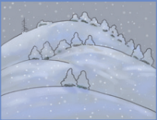
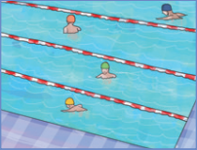
u Atmu n 2--- r w ntei 3--- msmure
_________ _______________ _____________

4- Read and answer .
What do you do every day ?
1-- I --------------------( wash ) my hands .
2- I------------------(-make ) my bed .
What does she do every day?
3- She ---------------( go ) to school .
4- She --------------( clean ) her bedroom .
5- Copy .
January February March April

