دولــــه فلسطين  وزارة التربية والتعليم  مديرية التربية والتعليم – طولكرم | 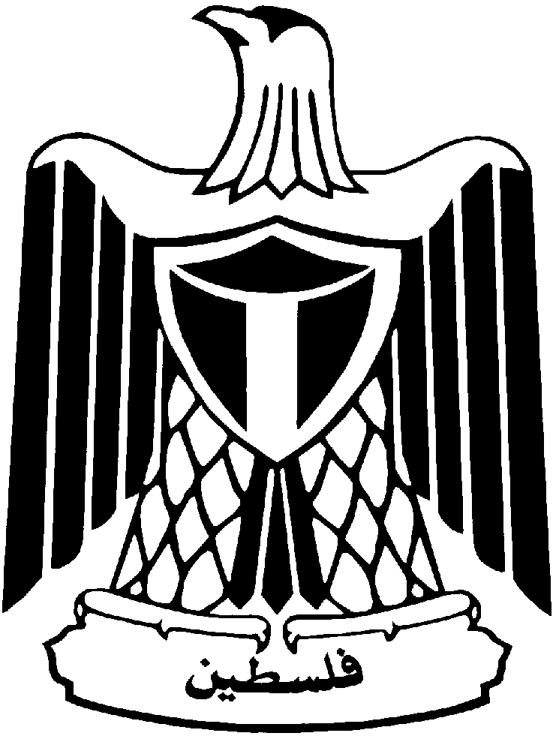 | State of Palestine
 |  | Ministry of Education & Higher Education
 |  | Directorate of Education/Tulkarm
Ektaba Boys' School
5th Grade
25)Marks (
Name: | Daily Exam | Date: …../……../2014
Reading {10 points}
(6 points)Q1:- Read the following passage and answer the following questions:
Reading
Read the passage then answer the questions :
Ben , Omar , Amy and Rania are drinking lemonade in the kitchen . They are looking at photos . Ben is showing Omar a photo of the Olympic stadium in London.

A) Read and Complete:
1-Ben , Omar , Amy and Rania are drinking …………….. in the kitchen
2- They are looking at ……………..
B) Get from passage :
a- a name of : 1- a drink ………………….. 2- city……..
3- building…………………..
C) Read and answer :
1- What is Ben showing Omar ?...........................................
2- Where is the Olympic stadium ?.........................................
Vocabulary {4 points}
Q2:-Finish the following sentences with words from the box below
building – cable car – stadium – wheel - boat
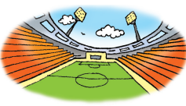
1. This is a football …………………..

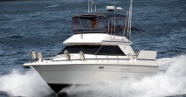
2. This is a little……………..
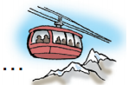
3. people can go up a mountain in a ………………..

4. the …………………goes round and round.

Speaking {4 points}

Q3:-Match ( A ) with ( B )

Match ( A ) with ( B ) :

B |  | A
Yes , I can. | ( ) | a- Where is the dome of the rock?
It's a bus and a boat . | ( ) | b- What is a duck bus ?
The dome of the rock is in Jerusalem. | ( ) |   c- Is mountain a building ?
No , it isn’t . | ( ) | d- Can you go hiking in a valley?
Language {4 points}

Correct the underlined verb: Q4:-
What are they doing now ?
1. They ………………..(look) at photos.
2. Ben …………………( show ) Omar a photo of the Olympic stadium.
3. Amy ………………..( hold ) a photo of the boat .
4. They ………………..( drink ) lemonade in the kitchen.

Writing {3 points}
Q5:-Punctuate:
1.amy is in the boat……………………………………….

2. ben and omar are good friends……………………………………….

Listening {4 points}

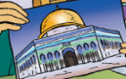
Q6:-listen and circle the correct words (5 points)

1. This is a photo of the ( dome of the rock - Al aqsa mosque ) . .
2. My parents go up the mountain in the ( cable car - bus ) .
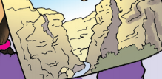
3.This is wadialqilt . it's a ( ugly - famous ) valley .
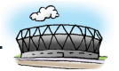
4. The Olympic stadium is a new ( place - building ) .
Good Luck
Teacher: SahirQalalweh

